**PROGRAM 5 :**

**Design an XML document to store information about a student in an engineering college affiliated to VTU. The information must include USN, Name, and Name of the College, Program, Year of Joining, and email id. Make up sample data for 3 students. Create a CSS style sheet and use it to display the document.**

**Prog5.xml**

<?xml-stylesheet type="text/css" href="prog5.css"?>

<!DOCTYPE HTML>

<html>

<head>

<h1> STUDENTS DESCRIPTION </h1>

</head>

<students>

<student>

<USN> USN : 1JT18IS055</USN>

<name>Name : SRICHARAN</name>

<college>COLLEGE : Jyothy Institute Of technology</college>

<branch>BRANCH : ISE</branch>

<year>YEAR : 2018</year>

<e-mail>E-Mail : sricharan@gmail.com</e-mail>

</student>

<student>

<USN>USN : 1JT21IS055 </USN>

<name>NAME : ANTONIO SOPRANOS </name>

<college>COLLEGE : Jyothy Institute Of technology</college>

<branch>BRANCH : ISE</branch>

<year>YEAR : 2021</year>

<e-mail>E-Mail : antonio@gmail.com</e-mail></student>

<student>

<USN>USN : 1JT20IS055</USN>

<name>NAME : ELLIOT ANDERSON </name>

<college>COLLEGE : Jyothy Institute Of technology</college>

<branch>BRANCH : ISE</branch>

<year>YEAR : 2020</year>

<e-mail>E-Mail : elliotanonymous@gmail.com</e-mail>

</student>

<student>

<USN>USN : 1JT19IS055</USN>

<name>NAME : JAMES ANDERSON </name>

<college>COLLEGE : Jyothy Institute Of technology</college>

<branch>BRANCH : ISE</branch>

<year>YEAR : 2019</year>

<e-mail>E-Mail :jamesanonymous@gmail.com</e-mail>

</student>

</students>

</html>

**Prog5.css**

student {

display: block;

margin-top: 20px;

color: Navy;

}

USN {

display: block;

margin-left: 20px;

font-size: 12pt;

color: Red;

}

name {

display: block;

margin-left: 20px;

font-size: 12pt;

color: Blue;

}

college {

display: block;

margin-left: 20px;

font-size: 12pt;

color: Maroon;

}

branch {

display: block;

margin-left: 20px;

font-size: 12pt;

color: Purple;

}

year {

display: block;

margin-left: 20px;

font-size: 12pt;

color: Green;

}

e-mail {

display: block;

margin-left: 20px;

font-size: 12pt;

color: Blue;

}

h1{

margin-left: 20px;

text-align: justify;

}

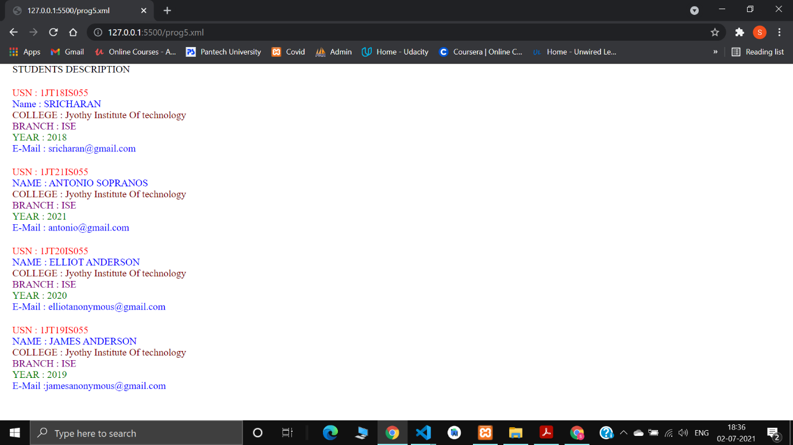

**PROGRAM 6:**

**Write a PHP program to keep track of the number of visitors visiting the**

**web page and to display this count of visitors, with proper headings.**

**Prog6.php**

<?php

$user = "Sricharan (1jt18is055)";

?>

“<style>

<?php include "main.css";?> //external ‘main.css’ file used for styling

</style>”

<!DOCTYPE html>

<html>

<head> <title> program 6 </title></head>

<body>

<h2> <?php echo $user; ?>, Welcome to Sample PHP Script </h2>

<h3>This program displays the number of page visits</h3>

<?php

print "<h3 style=color:white> REFRESH PAGE</h3>";

$name="counter.txt";

$file = fopen($name,"r");

$hits = fscanf($file,"%d");

fclose($file);

$hits[0]++;

$file = fopen($name,"w");

fprintf($file,"%d",$hits[0]);

fclose($file);

print "<h3 style=color:white>Total number of views: $hits[0]</h3>";

?>

</body>

</html>

**Main.css**

*{

font-family: sans-serif;

background-color:black;

}

title,h2{

text-align: center;

color: white;

}

h3{

color: white;

}

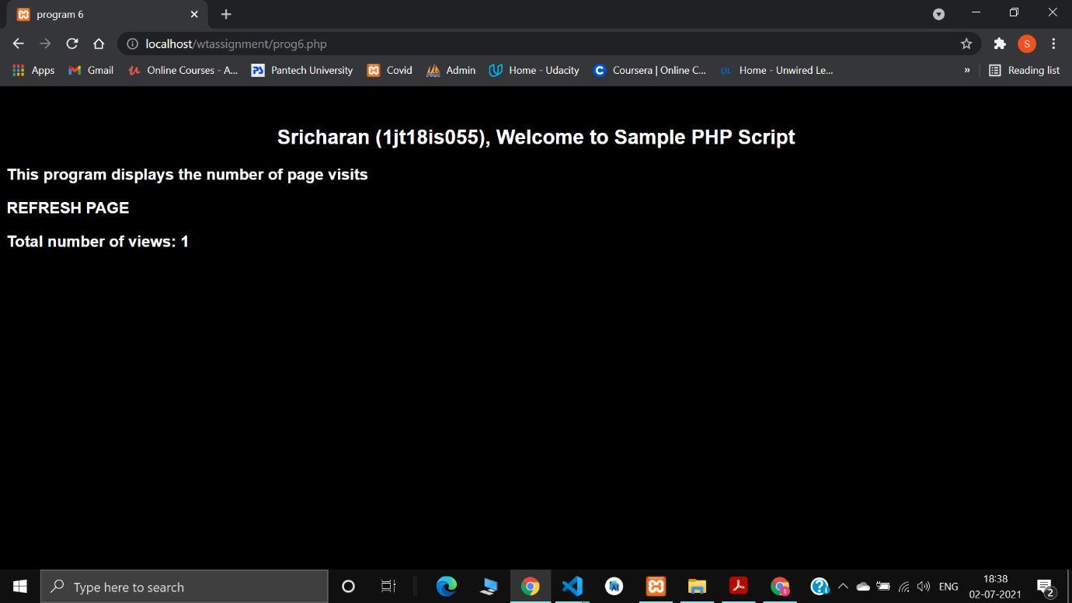

**PROGRAM 7:**

**Write a PHP program to display a digital clock which displays the current time of the server.**

**Code:**

<!DOCTYPE HTML>

<html>

<head>

<meta http-equiv="refresh" content="1" />

<style>

p {

color: white;

font-size: 50px;

position: absolute;

top: 40%;

left: 50%;

transform: translate(-50%, -50%);

}

body {

background-color: red;

}

</style>

<p> Server time is <?php echo date(" h:i:s A");?> <br>

Today is <?php echo date("Y/m/d");?> <br>

Today is <?php echo date("Y.m.d");?> <br>

Today is <?php echo date("Y-m-d");?> <br>

Today is <?php echo date("l");?>

</p>

</head>

</html>

